1. Project Overview
What problem does it solve?
FinAssist helps users manage their personal finances by tracking income, expenses, subscriptions, and financial goals. It analyzes financial data to identify spending patterns, summarize monthly finances, and determine how much users need to save to reach their goals.
Target Users:
The target users are students, young professionals, employees, freelancers, and other individuals who want to organize and better understand their personal finances.

What Can the Agent Do?
The agent can record income and expenses, analyze unusual spending, track financial goals and subscriptions, generate financial summaries, calculate required savings, and answer users' financial questions using their stored financial data.
Why Is an AI Agent Appropriate?
An AI agent is appropriate because users can ask financial questions in natural language, and answering them may require information from multiple parts of the system. The agent can determine which tools and data are needed, perform the required analysis, and provide a personalized response.
So the agent performs:
data retrieval → analysis → reasoning → recommendation
rather than simply generating text.
Which AI/LLM model(s) do you plan to use?
OpenAI GPT model for natural-language understanding, reasoning, and response generation. A speech-to-text model will also be used for voice-based financial logging.
The LLM is used for generating personalized recommendations and reasoning over retrieved financial information.
How will the AI model interact with the rest of the software system?
The user interacts with either the GUI or CLI (GUIView or CLIView), which sends requests to FinancialController. The controller calls FinAssistFacade, which passes AI requests to AgentOrchestrator. The orchestrator selects the right FinancialAgent (created through the AgentCreator factories), and the agent retrieves financial data through application services and FinancialRepository. Deterministic components perform financial calculations, while the LLM (through LLMService) interprets the results and generates natural-language responses.
Example workflow:
User → GUIView/CLIView → FinancialController → FinAssistFacade → AgentOrchestrator → FinancialAgent → LLMService → Response

2. Detailed Feature Specifications

F01 — Voice Financial Logging
The user records a financial transaction using the microphone through the GUI. The agent converts the speech to text, extracts information such as the transaction type, amount, merchant, category, and date, and validates the extracted information. The transaction details are displayed for the user to confirm before being saved. If the speech is unclear or required information is missing, the agent asks the user to repeat or clarify the transaction.

F02 — Expense Logging
The user enters an expense amount, date, category, merchant, and optional description through the GUI. The system validates the information and creates a new expense transaction, which is stored in the user's financial history. The dashboard and related financial calculations are updated automatically after the expense is saved. If required information is missing or invalid, the user is prompted to correct it.

F03 — Unusual Expense Detection
The agent analyzes a user's newly recorded expenses against their historical spending patterns to identify potentially unusual transactions. It compares factors such as amount and spending category, then uses the results to generate an explanation of why an expense differs from the user's normal pattern. The unusual expense is displayed as an alert in the GUI. If there is insufficient historical data, the system informs the user that a reliable comparison cannot yet be made.

F04 — Income & Profit Logging
The user enters income or profit information, including the amount, date, source, and type, through the GUI. The system validates and stores the information as an income transaction and updates the user's total income, savings calculations, and dashboard. If the entered amount or required information is invalid, the system asks the user to correct the entry.

F05 — End-of-Month Financial Summary
The user selects a month through the GUI, and the agent retrieves the user's financial data for that period. The system calculates total income, expenses, savings, savings rate, major spending categories, unusual expenses, and recurring subscription costs, then uses the LLM to generate a natural-language interpretation of the results. The completed financial summary is displayed in the GUI. If limited financial data is available, the system generates the summary using the available information and clearly identifies missing data.

F06 — Financial Goal Summary
The user creates or selects a financial goal by entering a goal name, target amount, current savings, and deadline through the GUI. The agent retrieves the user's financial information and calculates the goal's progress, remaining amount, and required monthly savings. The results are displayed as a goal summary with optional AI-generated explanations. If the goal has an invalid amount or expired deadline, the system asks the user to correct or update the goal.

F07 — Monthly Financial Dashboard
The user accesses the main dashboard through the GUI to view an overview of their financial situation. The system retrieves income, expenses, savings, financial goals, subscriptions, and unusual expense information and presents the results using financial metrics, charts, and progress indicators. The dashboard is automatically refreshed when relevant financial data changes. If no financial information has been entered, the system displays an empty dashboard with options to add transactions.

F08 — Personalized Savings Analyzer
The user selects a financial goal and requests a savings analysis through the GUI. The agent retrieves the user's income, expenses, current savings, goal amount, and deadline using its available tools, then calculates the required monthly savings and compares it with the user's current savings capacity. The LLM interprets the results and generates personalized suggestions based on the user's financial data. If information is insufficient, the agent identifies the missing data and explains the assumptions used in the analysis.

F09 — Subscription Tracking
The user adds and manages recurring expenses such as streaming services, memberships, and software subscriptions through the GUI. The system stores the subscription information, calculates its monthly and annual cost, and incorporates the recurring expense into the user's financial analysis and dashboard. The agent may identify recurring spending patterns and explain their impact on the user's finances. If subscription information is incomplete or invalid, the system asks the user to provide or correct the required details.

F10 — AI Financial Coach
The user enters a natural-language financial question through the AI Financial Coach interface in the GUI. The agent analyzes the user's request, determines which financial information is required, retrieves relevant data through its available tools, performs necessary financial calculations, and uses the LLM to generate a personalized response. The response is displayed in the conversational interface and can be followed by additional questions using the conversation context. If the agent cannot find the required information or the request is ambiguous, it asks the user for clarification rather than generating unsupported information.
3. UML Class Diagram:

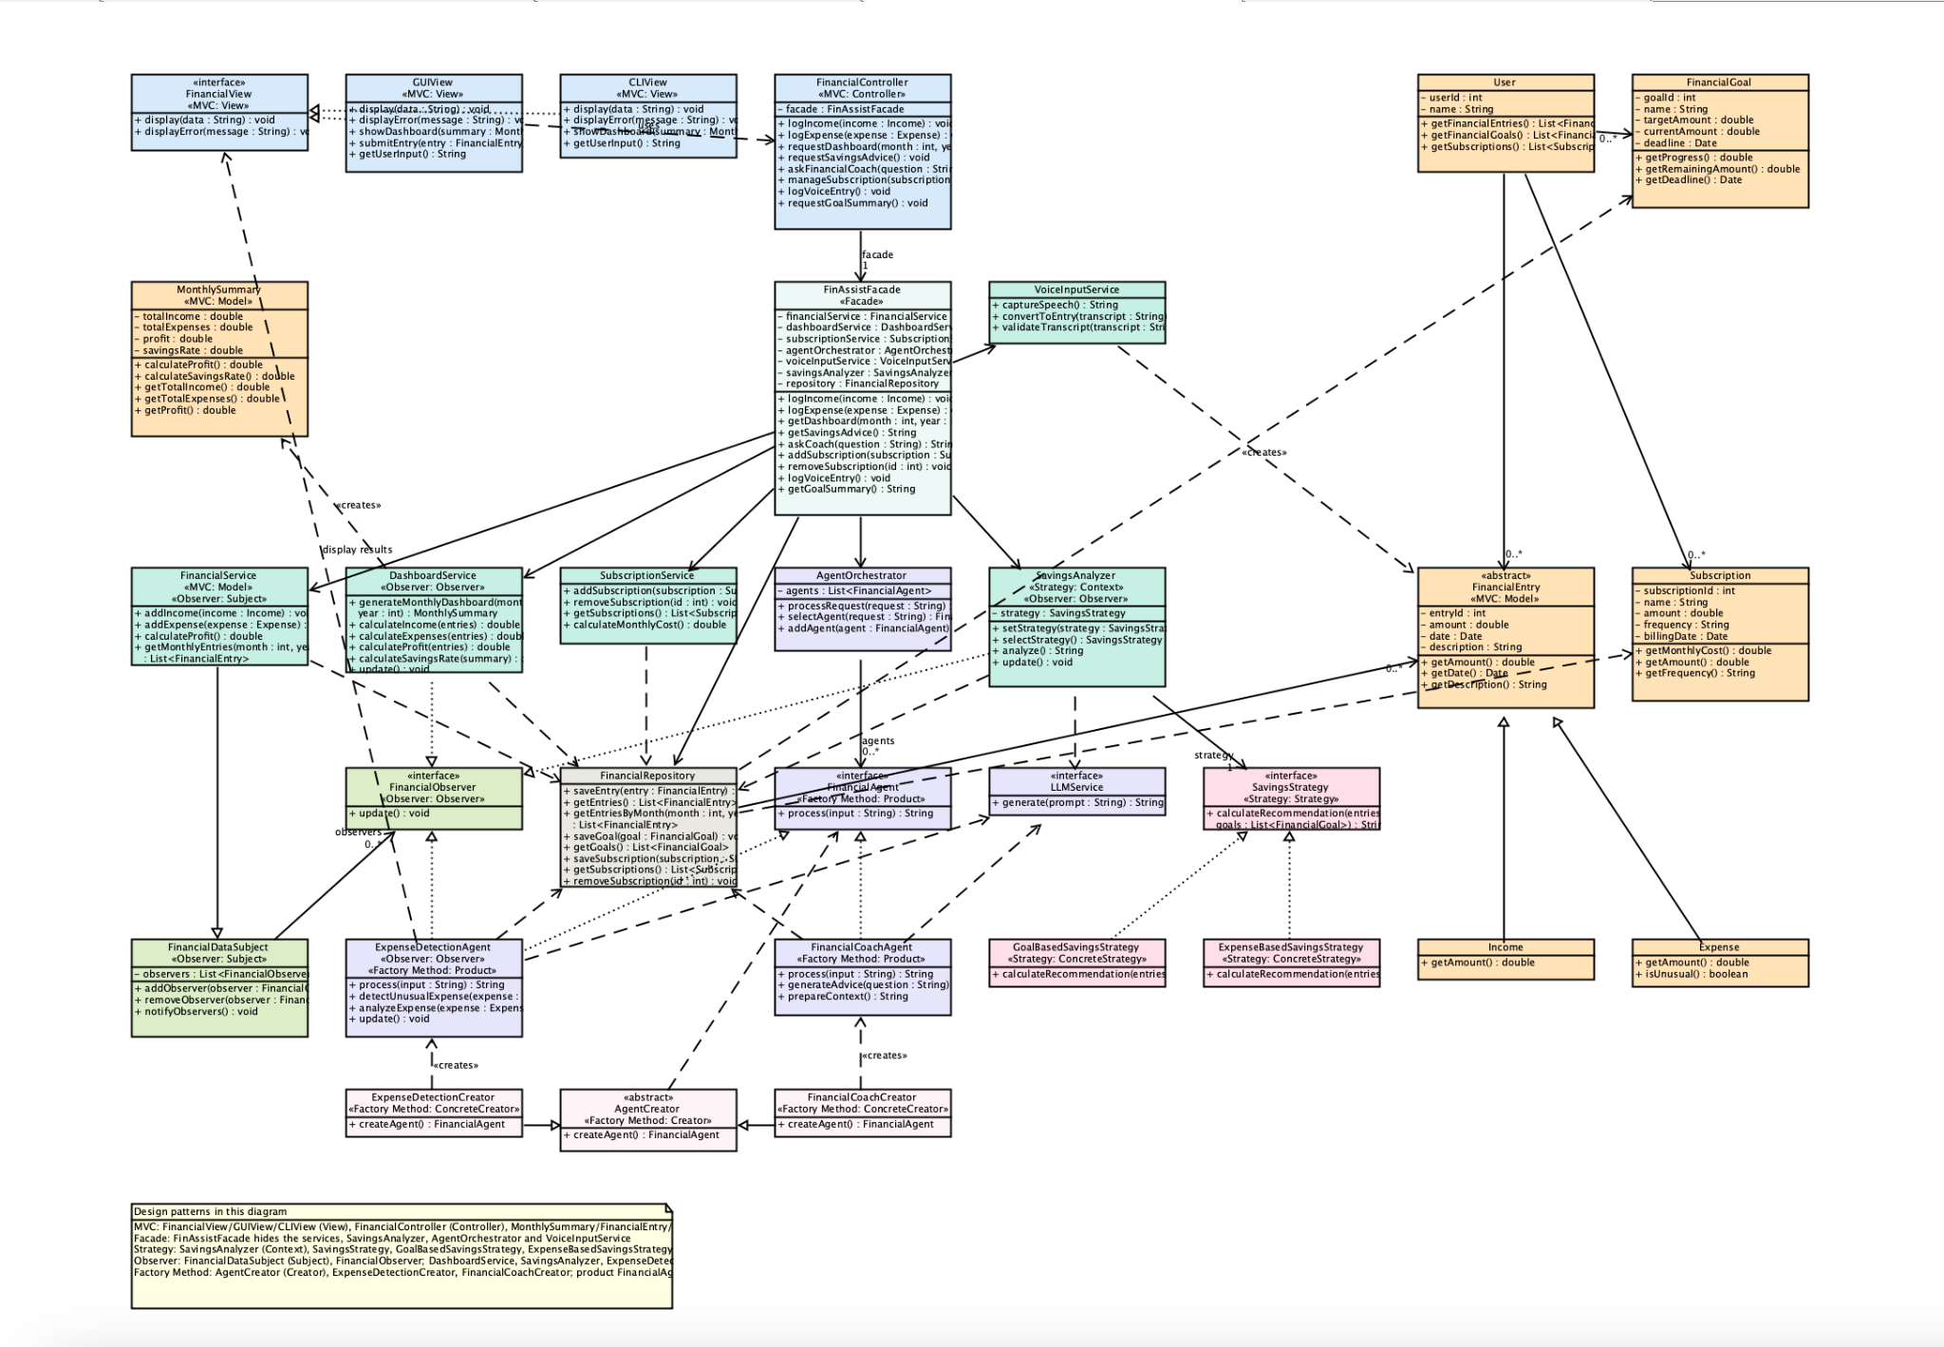

4. Design Pattern Explanations
FinAssist uses 5 design patterns: MVC, Facade, Strategy, Observer, and Factory Method.
1. MVC (Model-View-Controller)

What design problem does the pattern address?
FinAssist must support both a graphical user interface (GUI) and a command-line interface (CLI). Without a clear separation between the user interface and the financial/business logic, the application could become difficult to maintain because interface code, user input processing, and financial calculations would be mixed together.
MVC separates the application into three responsibilities:
- Model - represents financial data and business logic.
- View - displays information to the user.
- Controller - processes user requests and coordinates the Model and View.

Which classes participate in the pattern?
- FinancialController
- FinancialView
- GUIView
- CLIView
- Domain and service classes such as User, FinancialEntry, MonthlySummary, FinancialService, and DashboardService

What role does each class play?
- FinancialController - Controller. Receives user actions and coordinates the application.
- FinancialView - View interface that defines how information is presented.
- GUIView - Concrete View for the graphical interface.
- CLIView - Concrete View for the command-line interface.
- Domain/service classes - Model. They contain financial data and application logic.
Both GUIView and CLIView implement FinancialView, allowing the same application logic to support different interfaces.

Why is this pattern appropriate?
FinAssist is required to provide both a GUI and CLI. MVC allows both interfaces to use the same underlying financial logic without duplicating the Model.
For example, logging an expense should perform the same financial operation whether the user enters it through the GUI or CLI.

What would be more difficult without MVC?
Without MVC, the GUI and CLI could contain financial calculations and business logic themselves. This would lead to duplicated code and tightly coupled components.
Adding another interface, such as a mobile interface, would also require modifying or duplicating existing financial logic.
2. Facade

What design problem does the pattern address?
FinAssist contains several subsystems, including:
- FinancialService
- DashboardService
- SubscriptionService
- AgentOrchestrator
- SavingsAnalyzer
- VoiceInputService
If the controller or user interface had to communicate directly with all of these components, it would become tightly coupled to the internal architecture.

Which classes participate in the pattern?
- FinAssistFacade
- FinancialService
- DashboardService
- SubscriptionService
- AgentOrchestrator
- VoiceInputService
- SavingsAnalyzer
- FinancialController

What role does each class play?
- FinAssistFacade - Facade. Provides a simple interface to the underlying FinAssist subsystems.
- FinancialService - Handles income and expense operations.
- DashboardService - Generates monthly financial summaries and dashboard information.
- SubscriptionService - Manages subscriptions.
- AgentOrchestrator - Coordinates the AI agents.
- VoiceInputService - Captures, validates and converts spoken input.
- SavingsAnalyzer - Runs savings analysis using the selected strategy.
- FinancialController - Client that communicates primarily with the Facade rather than directly with every subsystem.
For example, the controller can call:
facade.getDashboard()
without needing to know how DashboardService generates the dashboard.

Why is this pattern appropriate?
FinAssist contains many different services and AI components. A Facade provides one simple entry point for the GUI/CLI layer while hiding the complexity of the underlying system.

What would be more difficult without the pattern?
Without the Facade, FinancialController would need to maintain references to many different services and understand how they interact.
Any change to the internal services could therefore require changes to the controller and possibly the user interface.
3. Strategy

What design problem does the pattern address?
FinAssist provides personalized savings recommendations. Different users may benefit from different ways of analyzing their finances.
For example, one strategy may focus primarily on financial goals, while another may focus on reducing unnecessary expenses.
Hard-coding all of these approaches into SavingsAnalyzer would create a large collection of conditional statements.

Which classes participate in the pattern?
- SavingsAnalyzer
- SavingsStrategy
- GoalBasedSavingsStrategy
- ExpenseBasedSavingsStrategy

What role does each class play?
- SavingsAnalyzer - Context. Uses a savings strategy to perform the analysis.
- SavingsStrategy - Strategy interface defining the common savings-analysis operation.
- GoalBasedSavingsStrategy - Concrete Strategy that generates recommendations based on the user's financial goals.
- ExpenseBasedSavingsStrategy - Concrete Strategy that generates recommendations based on the user's spending and expenses.
The SavingsAnalyzer contains a reference to the SavingsStrategy interface rather than directly depending on one specific strategy.

Why is this pattern appropriate?
Savings analysis is suited to multiple algorithms. Strategy allows FinAssist to change the analysis method without changing the SavingsAnalyzer itself. A new strategy, such as IncomeBasedSavingsStrategy, could be added later without rewriting the existing strategies.

What would be more difficult without the pattern?
Without Strategy, SavingsAnalyzer would likely contain many if/else statements to determine which calculation method to use.
Adding another analysis method would require modifying the existing class, making it larger and harder to test and maintain.
4. Observer

What design problem does the pattern address?
Financial information can change frequently. When a new income or expense is recorded, several parts of FinAssist may need to react to the change.
For example:
- The monthly dashboard may need to update.
- The unusual-expense detector may need to analyze the new expense.
- The savings analysis may need to use the updated financial information.
The component that changes the financial data should not have to know exactly which components need to be updated.

Which classes participate in the pattern?
- FinancialDataSubject
- FinancialService
- FinancialObserver
- DashboardService
- ExpenseDetectionAgent
- SavingsAnalyzer

What role does each class play?
- FinancialDataSubject - Subject. Maintains a list of observers and notifies them when financial data changes.
- FinancialService - Concrete Subject. Extends FinancialDataSubject and calls notifyObservers() after financial data is saved.
- FinancialObserver - Observer interface defining the update() operation.
- DashboardService - Concrete Observer that updates dashboard information.
- ExpenseDetectionAgent - Concrete Observer that can analyze financial changes for unusual expenses.
- SavingsAnalyzer - Concrete Observer that can update savings recommendations when financial information changes.
The concrete observers implement the FinancialObserver interface.

Why is this pattern appropriate?
Multiple components of FinAssist need to respond to financial-data changes. Observer allows these components to subscribe to updates without tightly coupling them to the component that changes the data.

What would be more difficult without the pattern?
Without Observer, FinancialService would have to explicitly call every component whenever financial data changed.
For example, adding a new AI analysis component would require modifying FinancialService to know about that component.
Observer allows new observers to be added without changing the subject.
5. Factory Method

What design problem does the pattern address?
FinAssist contains multiple specialized AI agents, such as:
- ExpenseDetectionAgent
- FinancialCoachAgent
The rest of the application should not need to know the details of how each concrete agent is created.
The system should be able to request an appropriate FinancialAgent while keeping the creation process separate from the code that uses the agent.

Which classes participate in the pattern?
For a proper Factory Method implementation, the pattern should use:
- FinancialAgent
- ExpenseDetectionAgent
- FinancialCoachAgent
- AgentCreator - abstract creator
- ExpenseDetectionAgentCreator - concrete creator
- FinancialCoachAgentCreator - concrete creator
- AgentOrchestrator - client

What role does each class play?
- FinancialAgent - Product interface representing an AI agent.
- ExpenseDetectionAgent - Concrete Product for detecting unusual expenses.
- FinancialCoachAgent - Concrete Product for providing personalized financial advice.
- AgentCreator - Creator containing the Factory Method for creating a FinancialAgent.
- ExpenseDetectionAgentCreator - Concrete Creator whose factory method creates an ExpenseDetectionAgent.
- FinancialCoachAgentCreator - Concrete Creator whose factory method creates a FinancialCoachAgent.
- AgentOrchestrator - Client that uses the resulting FinancialAgent without needing to know its concrete implementation.
The important idea is that the client works with FinancialAgent rather than directly depending on ExpenseDetectionAgent and FinancialCoachAgent

Why is this pattern appropriate?
The system can potentially support additional specialized agents in the future such as:
- InvestmentAgent
- BudgetAgent
- SubscriptionAgent
The Factory Method structure makes it possible to introduce new agent types while keeping agent creation separate from the code that uses the agents.

What would be more difficult without the pattern?
Without Factory Method, the application would need to directly instantiate concrete agents throughout the code.
For example:
- new ExpenseDetectionAgent();
- new FinancialCoachAgent();
would become scattered across controllers or other application classes.
Adding another agent would then require modifying those classes, increasing coupling between the application and concrete agent implementations.
5. Use-Case Diagram
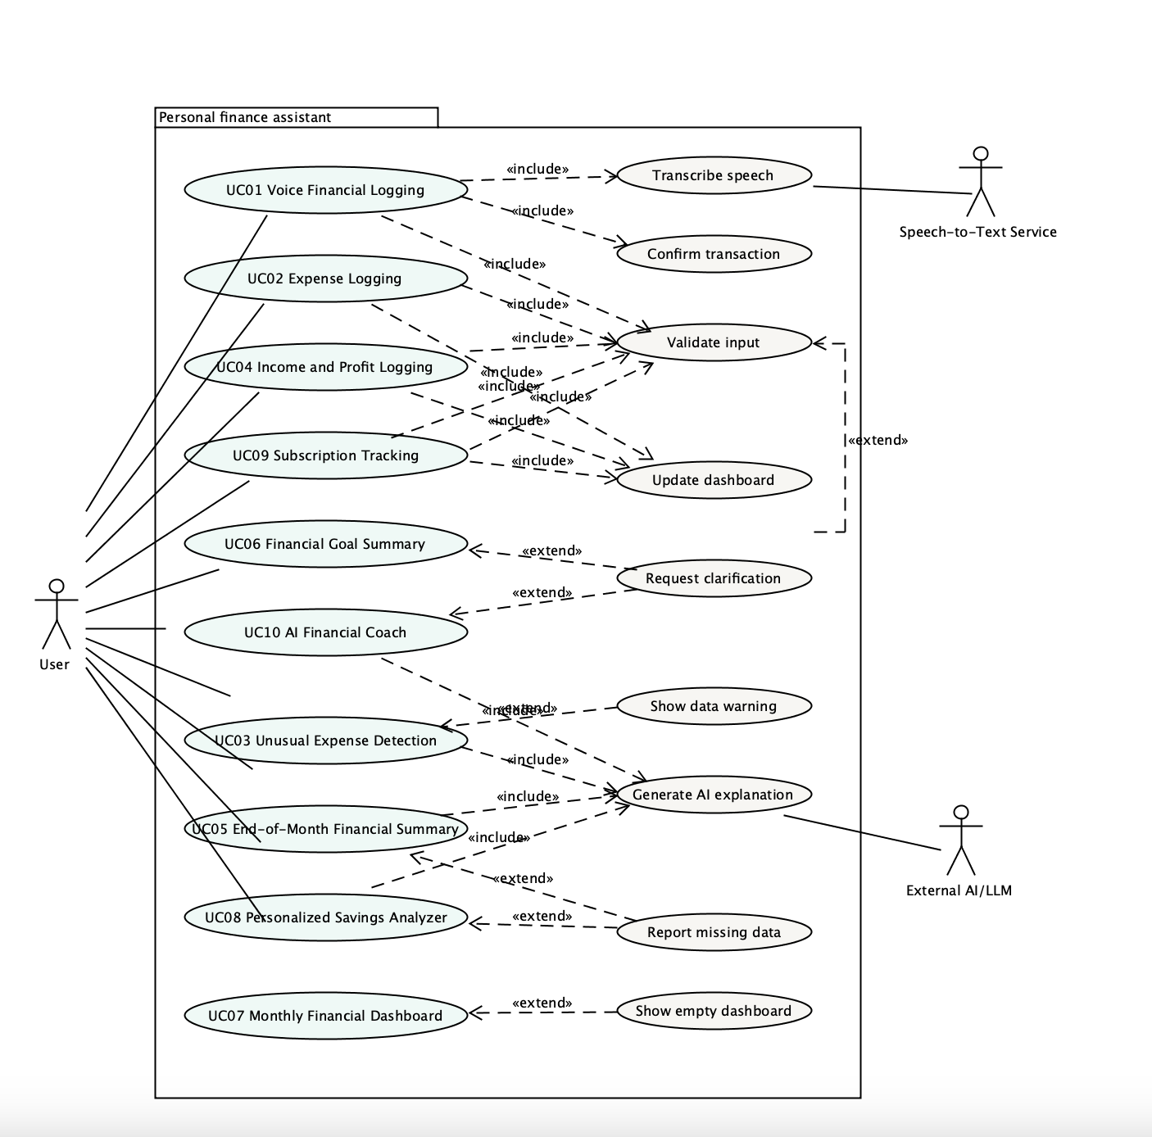
6. Detailed Use-Case Descriptions
Actors
- User is the primary actor and starts all ten features through the GUI.
- Speech-to-Text Service is a secondary actor that supports speech transcription in F01.
- External AI/LLM is a secondary actor that supports AI explanations, interpretations and suggestions.

UC01 — Voice Financial Logging
Use Case ID: UC01
Use Case Name: Voice Financial Logging
Actor(s): Primary User, Speech-to-Text Service
Goal: Allow the user to record a financial transaction by speaking instead of manually entering the information.
Related Feature: F01 — Voice Financial Logging

Preconditions
- The user has access to FinAssist.
- The device has a microphone or another supported audio input.
- The Speech-to-Text Service is available.

Trigger
The user selects the voice financial logging option and speaks a financial transaction.

Main Success Scenario
- The user selects Voice Financial Logging.
- FinAssist begins recording the user's voice input.
- The user describes a financial transaction.
- FinAssist sends the recorded audio to the Speech-to-Text Service.
- The Speech-to-Text Service converts the speech into text.
- FinAssist extracts the transaction information, such as amount, type, date, and description.
- FinAssist displays the interpreted transaction to the user.
- The user confirms the information.
- FinAssist stores the financial entry.
- FinAssist confirms that the entry was successfully recorded.

Alternative/Exception Flows
- A1: The Speech-to-Text Service cannot be reached. FinAssist displays an error and allows the user to enter the transaction manually.
- A2: The speech cannot be understood. FinAssist asks the user to repeat the transaction.
- A3: Required information such as the amount cannot be identified. FinAssist asks the user to provide the missing information.
- A4: The user rejects the interpreted transaction. FinAssist allows the user to correct or cancel it.

Postconditions
- A confirmed financial entry is stored in FinAssist.
- The user's financial data is updated.

UC02 — Expense Logging
Use Case ID: UC02
Use Case Name: Expense Logging
Actor(s): Primary User
Goal: Allow the user to record an expense and keep the dashboard and financial calculations up to date.
Related Feature: F02 — Expense Logging

Preconditions
- The user has access to FinAssist.
- The user has permission to add financial information.

Trigger
The user selects the expense logging function.

Main Success Scenario
- The user selects Log Expense.
- The user enters the expense amount, date, category, merchant, and an optional description.
- FinAssist validates the information.
- FinAssist stores the expense in the user's financial history.
- FinAssist updates the dashboard and related financial calculations automatically.
- FinAssist checks the new expense for unusual spending (see UC03).
- FinAssist confirms that the expense was saved.

Alternative/Exception Flows
- A1: The entered amount is invalid. FinAssist asks the user to enter a valid amount.
- A2: Required information is missing. FinAssist asks the user to provide the missing information.
- A3: The user cancels the operation. No expense is stored.

Postconditions
- The expense is stored in the user's financial history.
- The dashboard and related financial calculations are updated.

UC03 — Unusual Expense Detection
Use Case ID: UC03
Use Case Name: Unusual Expense Detection
Actor(s): Primary User, External AI/LLM
Goal: Identify expenses that appear unusual compared with the user's financial history or spending patterns.
Related Feature: F03 — Unusual Expense Detection

Preconditions
- The user has financial expense data recorded in FinAssist.
- The expense detection agent is available.
- The External AI/LLM is available when AI analysis is required.

Trigger
A new expense is recorded or the user requests an expense analysis.

Main Success Scenario
- FinAssist receives a new expense.
- The expense is passed to the Expense Detection Agent.
- The agent retrieves relevant financial history.
- The agent analyzes the expense against the user's previous spending patterns.
- The agent uses the External AI/LLM when additional AI analysis is required.
- The system determines whether the expense appears unusual.
- If the expense is unusual, FinAssist informs the user and provides an explanation.
- The result is displayed to the user.

Alternative/Exception Flows
- A1: There is insufficient historical data. FinAssist informs the user that a reliable comparison cannot yet be made.
- A2: The External AI/LLM is unavailable. FinAssist informs the user that AI analysis is temporarily unavailable.
- A3: The expense is determined to be normal. FinAssist records the result without generating an unusual-expense warning.

Postconditions
- The expense remains recorded.
- If applicable, an unusual-expense notification or analysis is provided to the user.

UC04 — Income and Profit Logging
Use Case ID: UC04
Use Case Name: Income and Profit Logging
Actor(s): Primary User
Goal: Allow the user to record income and determine financial profit based on income and expenses.
Related Feature: F04 — Income & Profit Logging

Preconditions
- The user has access to FinAssist.
- The user has permission to add financial information.

Trigger
The user selects the income logging function.

Main Success Scenario
- The user selects Log Income.
- The user enters the income amount, date, and description.
- FinAssist validates the information.
- FinAssist stores the income entry.
- FinAssist retrieves relevant income and expense information.
- FinAssist calculates profit.
- FinAssist displays the updated profit to the user.

Alternative/Exception Flows
- A1: The entered amount is invalid. FinAssist asks the user to enter a valid amount.
- A2: Required information is missing. FinAssist asks the user to provide the missing information.
- A3: The user cancels the operation. No income entry is stored.

Postconditions
- The income entry is stored.
- The user's calculated profit is updated.

UC05 — End-of-Month Financial Summary
Use Case ID: UC05
Use Case Name: End-of-Month Financial Summary
Actor(s): Primary User, External AI/LLM
Goal: Give the user a summary of a chosen month with a natural-language interpretation of the results.
Related Feature: F05 — End-of-Month Financial Summary

Preconditions
- The user has access to FinAssist.
- Financial data may exist for the selected month.

Trigger
The user selects the End-of-Month Financial Summary.

Main Success Scenario
- The user selects a month.
- FinAssist retrieves the financial entries for that month.
- FinAssist calculates total income, expenses, savings and savings rate.
- FinAssist identifies major spending categories, unusual expenses and recurring subscription costs.
- FinAssist sends the results to the External AI/LLM.
- The External AI/LLM generates a natural-language interpretation of the results.
- FinAssist displays the summary and interpretation to the user.

Alternative/Exception Flows
- A1: Limited financial data is available. FinAssist generates the summary from the available information and clearly identifies the missing data.
- A2: The External AI/LLM is unavailable. FinAssist displays the calculated figures and informs the user that the AI interpretation is temporarily unavailable.

Postconditions
- The end-of-month summary is displayed.
- No financial data is changed.

UC06 — Financial Goal Summary
Use Case ID: UC06
Use Case Name: Financial Goal Summary
Actor(s): Primary User
Goal: Allow the user to view progress toward financial goals.
Related Feature: F06 — Financial Goal Summary

Preconditions
- The user has access to FinAssist.
- At least one financial goal may exist.

Trigger
The user selects the Financial Goal Summary option.

Main Success Scenario
- The user requests the Financial Goal Summary.
- FinAssist retrieves the user's financial goals.
- FinAssist calculates the progress of each goal.
- FinAssist determines remaining amounts and relevant deadlines.
- FinAssist displays the goal summary to the user.

Alternative/Exception Flows
- A1: The user has no financial goals. FinAssist informs the user and provides an option to create a goal.
- A2: A goal contains invalid or incomplete information. FinAssist identifies the affected goal and requests correction.

Postconditions
- The user can view the current status and progress of their financial goals.
- No financial data is changed.

UC07 — Monthly Financial Dashboard
Use Case ID: UC07
Use Case Name: Monthly Financial Dashboard
Actor(s): Primary User
Goal: Provide the user with an overview of monthly financial activity.
Related Feature: F07 — Monthly Financial Dashboard

Preconditions
- The user has access to FinAssist.
- Financial data may exist for the selected month.

Trigger
The user selects the Monthly Financial Dashboard.

Main Success Scenario
- The user requests the monthly dashboard.
- FinAssist retrieves the selected month's financial entries.
- FinAssist calculates total income.
- FinAssist calculates total expenses.
- FinAssist calculates profit.
- FinAssist prepares the monthly summary.
- FinAssist displays the dashboard to the user.

Alternative/Exception Flows
- A1: No financial entries exist for the selected month. FinAssist displays an empty or zero-value dashboard.
- A2: The selected date or month is invalid. FinAssist asks the user to select a valid period.

Postconditions
- The monthly financial summary is displayed.
- No financial data is changed.

UC08 — Personalized Savings Analyzer
Use Case ID: UC08
Use Case Name: Personalized Savings Analyzer
Actor(s): Primary User, External AI/LLM
Goal: Analyze the user's financial situation and provide personalized savings recommendations.
Related Feature: F08 — Personalized Savings Analyzer

Preconditions
- The user has financial information recorded in FinAssist.
- The savings analyzer is available.
- The External AI/LLM is available when AI-generated recommendations are required.

Trigger
The user requests personalized savings analysis.

Main Success Scenario
- The user selects Personalized Savings Analysis.
- FinAssist retrieves the user's income, expenses, and financial goals.
- The Savings Analyzer evaluates the user's financial situation.
- The appropriate savings strategy is selected.
- The system generates savings recommendations.
- The External AI/LLM may be used to personalize and explain the recommendations.
- FinAssist displays the recommendations to the user.

Alternative/Exception Flows
- A1: The user has insufficient financial information. FinAssist explains what information is needed for a meaningful analysis.
- A2: The External AI/LLM is unavailable. FinAssist informs the user that personalized AI recommendations are temporarily unavailable.
- A3: No financial goals have been created. FinAssist provides general savings recommendations and suggests creating a financial goal.

Postconditions
- Personalized savings recommendations are displayed.
- No financial transactions are automatically created.

UC09 — Subscription Tracking
Use Case ID: UC09
Use Case Name: Subscription Tracking
Actor(s): Primary User
Goal: Allow the user to record, view, update, and remove recurring subscriptions and monitor their recurring costs.
Related Feature: F09 — Subscription Tracking

Preconditions
- The user has access to FinAssist.
- The user can access the Subscription Tracking functionality.

Trigger
The user selects the Subscription Tracking feature.

Main Success Scenario
- The user opens Subscription Tracking.
- FinAssist displays the user's existing subscriptions.
- The user chooses to add, update, or remove a subscription.
- If adding a subscription, the user enters information such as the subscription name, amount, billing frequency, and billing date.
- FinAssist validates the entered information.
- FinAssist stores or updates the subscription information.
- FinAssist calculates the user's total recurring subscription cost.
- FinAssist displays the updated subscription list and recurring cost to the user.

Alternative/Exception Flows
- A1: The subscription amount is invalid. FinAssist asks the user to enter a valid amount.
- A2: Required subscription information is missing. FinAssist asks the user to provide the missing information.
- A3: The user attempts to update or remove a subscription that does not exist. FinAssist displays an appropriate error message.
- A4: The user cancels the operation. No changes are made.
- A5: A duplicate subscription is detected. FinAssist warns the user and allows them to confirm whether it should be added.

Postconditions
- The subscription information is stored, updated, or removed as requested.
- The user's recurring subscription cost is recalculated.
- Updated subscription information is available for financial summaries and analysis.

UC10 — AI Financial Coach
Use Case ID: UC10
Use Case Name: AI Financial Coach
Actor(s): Primary User, External AI/LLM
Goal: Allow the user to ask financial questions and receive personalized AI-generated guidance based on their financial information and goals.
Related Feature: F10 — AI Financial Coach

Preconditions
- The user has access to FinAssist.
- The Financial Coach Agent is available.
- The External AI/LLM is available.
- Relevant financial information may be available in the user's FinAssist account.

Trigger
The user enters a financial question or requests advice from the AI Financial Coach.

Main Success Scenario
- The user opens the AI Financial Coach.
- The user enters a financial question or request.
- FinAssist sends the request to the Financial Coach Agent.
- The Financial Coach Agent identifies the type of financial guidance requested.
- The agent retrieves relevant information from the user's financial records, such as income, expenses, financial goals, subscriptions, and savings information.
- The agent prepares the relevant financial information as context for the External AI/LLM.
- The External AI/LLM analyzes the request and generates a response.
- The Financial Coach Agent processes the generated response.
- FinAssist displays the personalized financial guidance to the user.
- The user can ask a follow-up question if additional guidance is required.

Alternative/Exception Flows
- A1: The user's question is unclear. The Financial Coach asks the user to clarify the question.
- A2: There is insufficient financial information to provide personalized guidance. FinAssist explains what additional information would improve the recommendation.
- A3: The External AI/LLM is unavailable. FinAssist informs the user that AI coaching is temporarily unavailable.
- A4: The AI service returns an invalid or unusable response. FinAssist informs the user and allows them to try the request again.
- A5: The user asks a question outside the supported financial-coaching functionality. FinAssist explains the supported capabilities and asks the user to provide a relevant financial question.

Postconditions
- The user receives an AI-generated financial coaching response when the AI service is available.
- The user's financial records are not changed automatically by the coaching interaction.
- The conversation may provide recommendations based on the user's current financial information.
7. Sequence Diagrams
SD-01— Financial Entry Logging:
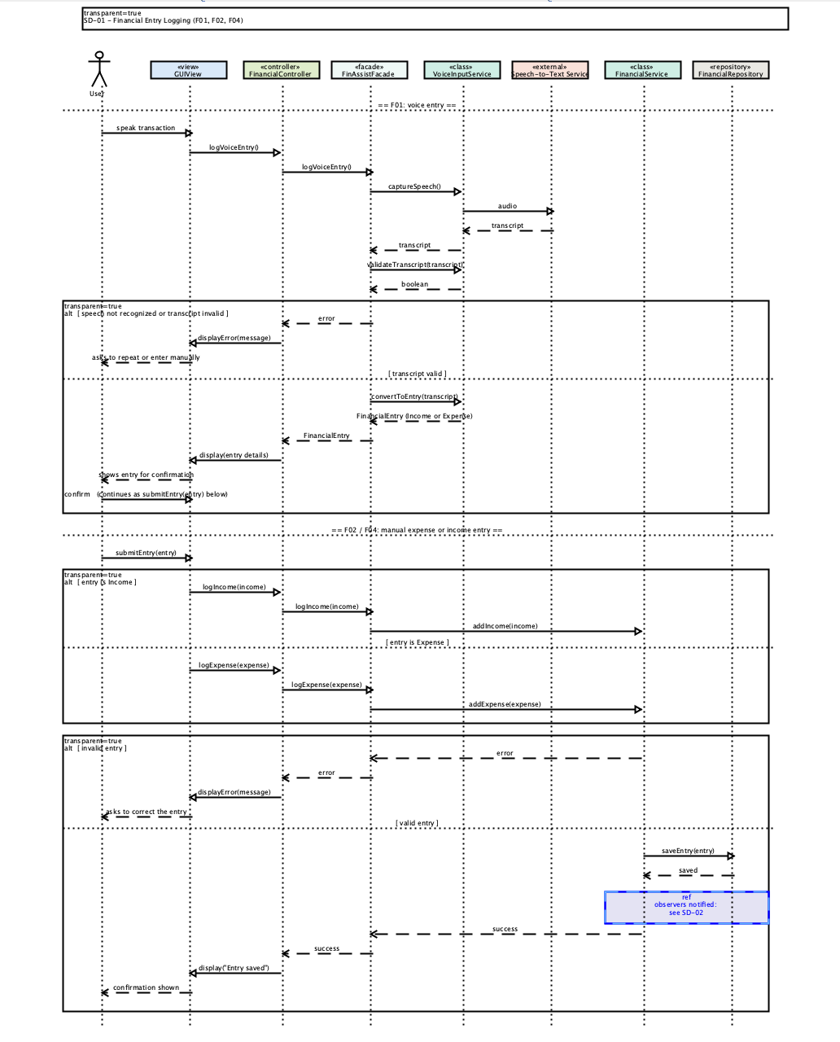
SD-02 — Unusual Expense Detection:
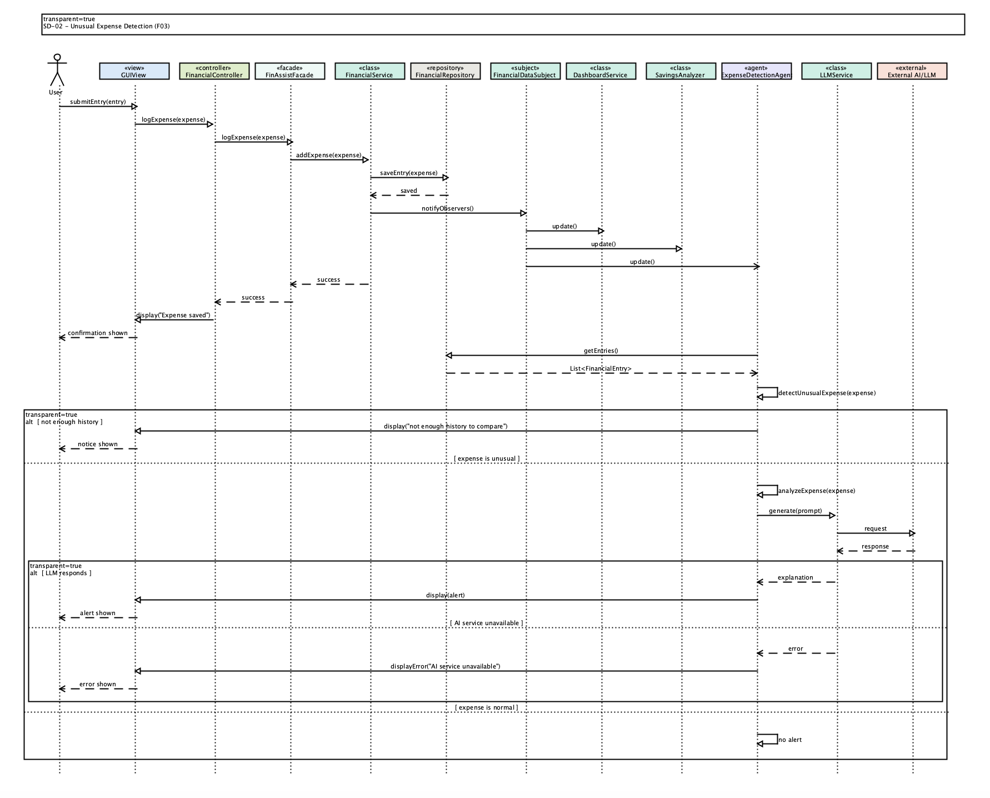
SD-03 — Financial Summaries and Dashboard:
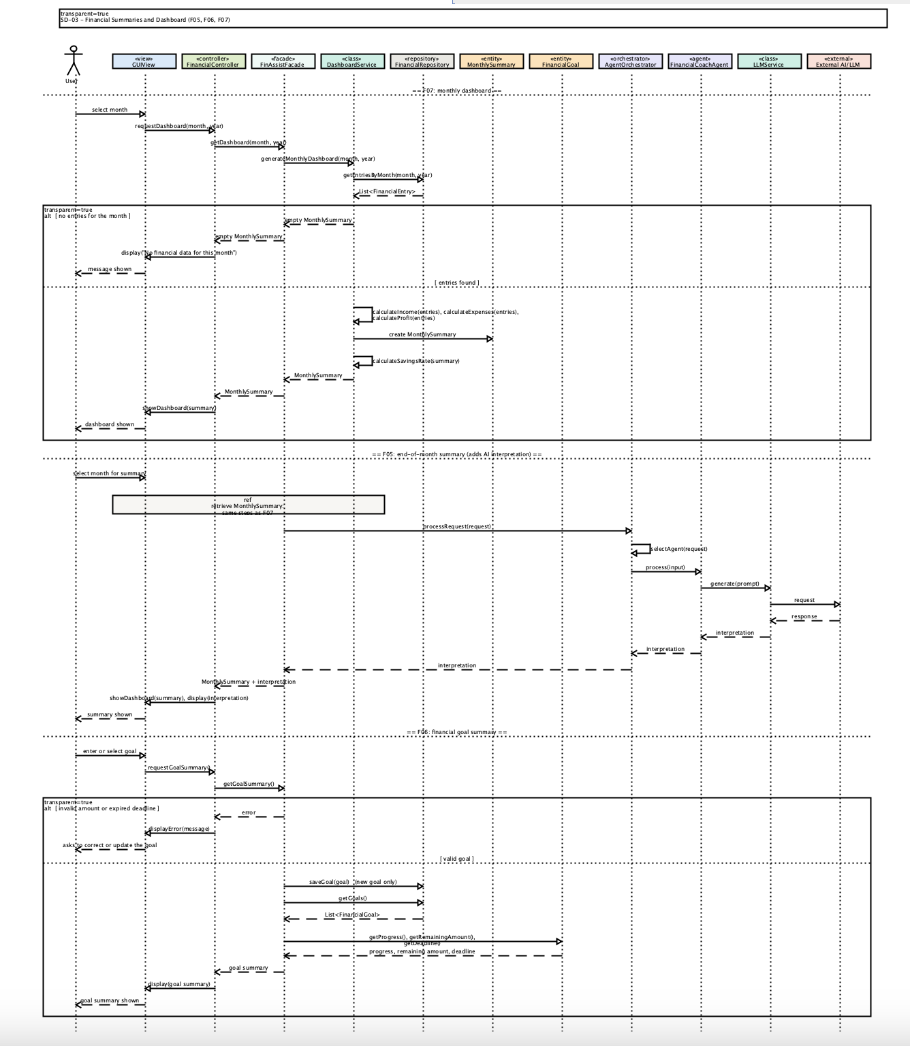
SD-04 — Savings Analysis and Subscription Tracking:
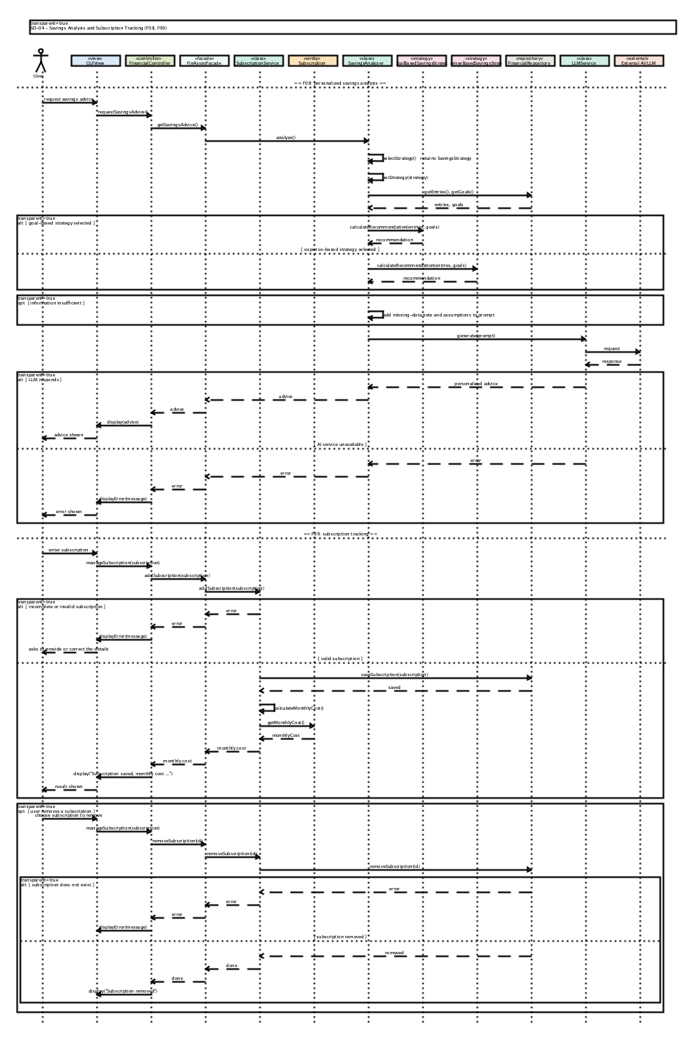
SD-05 — AI Financial Coaching:
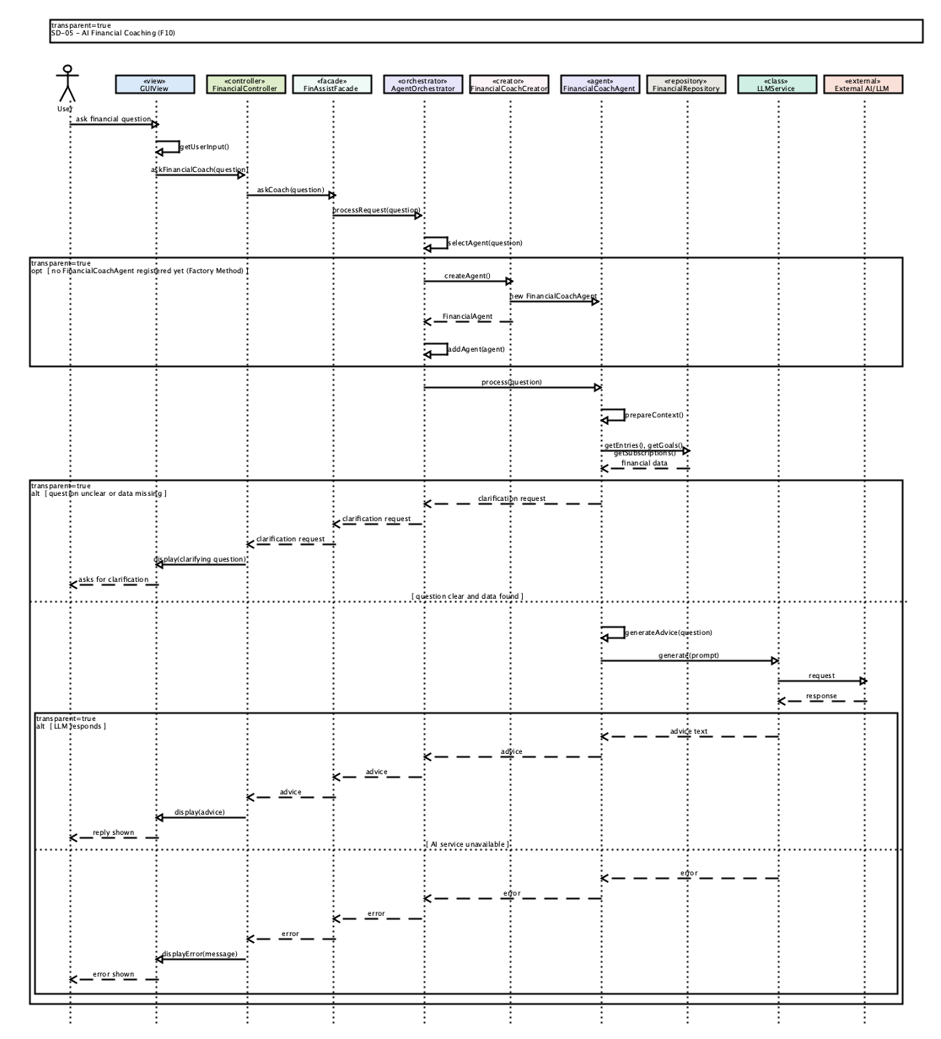
8. Feature-to-Design Traceability Table
Feature | Description | Type | Use case | Related classes | Key methods | Sequence diagram | Design pattern(s)
F01 | Voice financial logging: speak a transaction, review the extracted entry, confirm and save | Hybrid | UC01 Voice Financial Logging | GUIView, FinancialController, FinAssistFacade, VoiceInputService, Speech-to-Text Service, FinancialService, FinancialRepository, Income, Expense | captureSpeech(), validateTranscript(), convertToEntry(), display(), displayError(), submitEntry(), logIncome(), logExpense(), addIncome(), addExpense(), saveEntry(), logVoiceEntry() | SD-01 | MVC, Facade
F02 | Expense logging: enter an expense in the GUI, validate and store it | Deterministic | UC02 Expense Logging | GUIView, FinancialController, FinAssistFacade, FinancialService, FinancialRepository, Expense | submitEntry(), logExpense(), addExpense(), saveEntry(), display(), displayError() | SD-01, SD-02 | MVC, Facade, Observer
F03 | Unusual expense detection: compare a new expense with past spending, show an alert with an AI explanation | Hybrid | UC03 Unusual Expense Detection | FinancialService, FinancialRepository, FinancialDataSubject, DashboardService, SavingsAnalyzer, ExpenseDetectionAgent, LLMService, External AI/LLM, FinAssistFacade, FinancialController, GUIView | notifyObservers(), update(), getEntries(), detectUnusualExpense(), analyzeExpense(), generate(), display(), displayError() | SD-02 | Observer, Facade, MVC
F04 | Income and profit logging: enter income, validate and store it, update totals and savings | Deterministic | UC04 Income and Profit Logging | GUIView, FinancialController, FinAssistFacade, FinancialService, FinancialRepository, Income, DashboardService, MonthlySummary | submitEntry(), logIncome(), addIncome(), saveEntry(), generateMonthlyDashboard(), calculateProfit(), calculateSavingsRate(), display(), displayError() | SD-01, SD-03 | MVC, Facade
F05 | End-of-month summary: totals, savings rate and an LLM-written interpretation for a chosen month | Hybrid | UC05 End-of-Month Financial Summary | GUIView, FinancialController, FinAssistFacade, DashboardService, FinancialRepository, MonthlySummary, AgentOrchestrator, FinancialCoachAgent, LLMService, External AI/LLM | requestDashboard(), getDashboard(), generateMonthlyDashboard(), getEntriesByMonth(), calculateIncome(), calculateExpenses(), calculateProfit(), calculateSavingsRate(), processRequest(), selectAgent(), process(), generate(), showDashboard(), display() | SD-03 | MVC, Facade
F06 | Financial goal summary: save a goal and show progress, remaining amount and deadline | Deterministic | UC06 Financial Goal Summary | GUIView, FinancialController, FinAssistFacade, FinancialGoal, FinancialRepository | requestGoalSummary(), getGoalSummary(), saveGoal(), getGoals(), getProgress(), getRemainingAmount(), getRequiredMonthlySavings(), getDeadline(), display(), displayError() | SD-03 | MVC, Facade
F07 | Monthly dashboard: income, expenses, savings and progress for a chosen month | Deterministic | UC07 Monthly Financial Dashboard | GUIView, FinancialController, FinAssistFacade, DashboardService, FinancialRepository, MonthlySummary | requestDashboard(), getDashboard(), generateMonthlyDashboard(), getEntriesByMonth(), calculateIncome(), calculateExpenses(), calculateProfit(), calculateSavingsRate(), showDashboard(), update() | SD-03, SD-02 | MVC, Facade, Observer
F08 | Personalized savings analyzer: recommend how to reach a goal, worded by the LLM | Hybrid | UC08 Personalized Savings Analyzer | GUIView, FinancialController, FinAssistFacade, SavingsAnalyzer, SavingsStrategy, GoalBasedSavingsStrategy, ExpenseBasedSavingsStrategy, FinancialRepository, LLMService, External AI/LLM | requestSavingsAdvice(), getSavingsAdvice(), analyze(), selectStrategy(), setStrategy(), calculateRecommendation(), getEntries(), getGoals(), generate(), display() | SD-04 | Strategy, Facade, MVC
F09 | Subscription tracking: add and remove recurring expenses and calculate their monthly cost | Deterministic | UC09 Subscription Tracking | GUIView, FinancialController, FinAssistFacade, SubscriptionService, Subscription, FinancialRepository | manageSubscription(), addSubscription(), removeSubscription(), calculateMonthlyCost(), getMonthlyCost(), getAnnualCost(), saveSubscription(), display(), displayError() | SD-04 | MVC, Facade
F10 | AI financial coach: answer natural-language questions using the user's own data | AI | UC10 AI Financial Coach | GUIView, FinancialController, FinAssistFacade, AgentOrchestrator, FinancialCoachAgentCreator, FinancialCoachAgent, FinancialRepository, LLMService, External AI/LLM | getUserInput(), askFinancialCoach(), askCoach(), processRequest(), selectAgent(), createAgent(), addAgent(), process(), prepareContext(), getEntries(), getGoals(), getSubscriptions(), generateAdvice(), generate(), display() | SD-05 | MVC, Facade, Factory Method

9. Feature Implementation Explanations
Every feature follows the same MVC path: GUIView calls FinancialController, which calls FinAssistFacade, which calls a service or agent.

F01 — Voice Financial Logging
Related use case: UC01 — Voice Financial Logging
Related sequence diagram: SD-01 — Financial Entry Logging
Classes
- GUIView - takes the spoken input, then shows the extracted entry for confirmation or an error.
- FinancialController - receives the request and passes it to the facade.
- FinAssistFacade - calls VoiceInputService and, after confirmation, the financial service.
- VoiceInputService - captures the speech, validates the transcript and converts it into an entry.
- Speech-to-Text Service (external, ChatGPT) - turns the audio into a transcript.
- FinancialService, FinancialRepository - record and store the confirmed entry.
- Income / Expense - the entry that is created.
Important methods: FinancialController.logVoiceEntry(), FinAssistFacade.logVoiceEntry(), VoiceInputService.captureSpeech(), validateTranscript(), convertToEntry(), GUIView.display(), displayError(), submitEntry(), FinancialService.addIncome() / addExpense(), FinancialRepository.saveEntry().
Execution: The user speaks, and logVoiceEntry() passes from FinancialController to FinAssistFacade, which calls captureSpeech(). The Speech-to-Text Service returns a transcript, and validateTranscript() checks it. If the speech is unclear, displayError() asks the user to repeat it or enter the transaction manually. Otherwise convertToEntry() builds an Income or Expense and display() shows it for confirmation. After the user confirms, the entry follows the same path as F02 and F04.

F02 — Expense Logging
Related use case: UC02 — Expense Logging
Related sequence diagrams: SD-01 — Financial Entry Logging, SD-02 — Unusual Expense Detection
Classes
- GUIView - collects amount, date, category, merchant and description.
- FinancialController - receives the expense from the view.
- FinAssistFacade - single entry point to the services.
- FinancialService - records the expense.
- FinancialRepository - stores it.
- Expense - the entry being created.
Important methods: GUIView.submitEntry(), FinancialController.logExpense(), FinAssistFacade.logExpense(), FinancialService.addExpense(), FinancialRepository.saveEntry(), GUIView.display(), displayError().
Execution: submitEntry() passes the expense through logExpense() on the controller and facade to addExpense(). An invalid entry returns an error, and displayError() asks the user to correct it. A valid entry is stored with saveEntry() and the user sees a confirmation. SD-02 shows what happens next: the observers are notified, so the dashboard and unusual-expense check run.

F03 — Unusual Expense Detection
Related use case: UC03 — Unusual Expense Detection
Related sequence diagram: SD-02 — Unusual Expense Detection
Classes
- FinancialService, FinancialRepository - save the new expense.
- FinancialDataSubject - notifies the observers after the save.
- DashboardService, SavingsAnalyzer - refresh their data when notified.
- ExpenseDetectionAgent - compares the expense with past spending.
- LLMService, External AI/LLM - write the explanation.
- GUIView - shows the alert or error; ExpenseDetectionAgent calls display() and displayError() on it directly.
Important methods: FinancialDataSubject.notifyObservers(), update(), ExpenseDetectionAgent.detectUnusualExpense(), analyzeExpense(), FinancialRepository.getEntries(), LLMService.generate(), GUIView.display(), displayError() (called directly by ExpenseDetectionAgent).
Execution: After saveEntry(), FinancialService triggers notifyObservers(), which calls update() on DashboardService, SavingsAnalyzer and ExpenseDetectionAgent. The agent loads past entries with getEntries() and runs detectUnusualExpense(). With too little history, the user is told a reliable comparison is not possible yet. For an unusual expense, analyzeExpense() calls generate() for an explanation, and the alert is displayed. If the LLM is unavailable, an error message is shown and no other fallback is used.

F04 — Income & Profit Logging
Related use case: UC04 — Income and Profit Logging
Related sequence diagrams: SD-01 — Financial Entry Logging, SD-03 — Financial Summaries and Dashboard
Classes
- GUIView - collects amount, date, source and type.
- FinancialController, FinAssistFacade - pass the income down.
- FinancialService - records the income.
- FinancialRepository - stores it.
- Income - the entry being created.
- DashboardService, MonthlySummary - produce total income, profit and savings rate.
Important methods: GUIView.submitEntry(), FinancialController.logIncome(), FinAssistFacade.logIncome(), FinancialService.addIncome(), FinancialRepository.saveEntry(), DashboardService.generateMonthlyDashboard(), MonthlySummary.calculateProfit(), calculateSavingsRate().
Execution: The path matches F02 but goes through logIncome() and addIncome(). An invalid amount returns an error and displayError() asks the user to correct it. A valid income is stored with saveEntry(). The updated totals appear the next time the dashboard is generated (SD-03), where DashboardService and MonthlySummary calculate profit and savings rate.

F05 — End-of-Month Financial Summary
Related use case: UC05 — End-of-Month Financial Summary
Related sequence diagram: SD-03 — Financial Summaries and Dashboard
Classes
- GUIView - lets the user pick a month and displays the summary.
- FinancialController, FinAssistFacade - pass the request down.
- DashboardService - builds the monthly figures.
- FinancialRepository - supplies the month's entries.
- MonthlySummary - holds income, expenses, profit and savings rate.
- AgentOrchestrator, FinancialCoachAgent - route the request and prepare the interpretation.
- LLMService, External AI/LLM - write the natural-language interpretation.
Important methods: FinancialController.requestDashboard(), FinAssistFacade.getDashboard(), DashboardService.generateMonthlyDashboard(), calculateIncome(), calculateExpenses(), calculateProfit(), calculateSavingsRate(), FinancialRepository.getEntriesByMonth(), AgentOrchestrator.processRequest(), selectAgent(), FinancialCoachAgent.process(), LLMService.generate(), GUIView.showDashboard(), display().
Execution: The user selects a month, and the figures are produced the same way as in F07 (generateMonthlyDashboard() on the entries from getEntriesByMonth()). The facade then calls processRequest(), which selects FinancialCoachAgent. The agent calls generate() to write the interpretation. GUIView shows the figures and the text together. If the month has little data, the summary uses what exists and the interpretation should name what is missing.

F06 — Financial Goal Summary
Related use case: UC06 — Financial Goal Summary
Related sequence diagram: SD-03 — Financial Summaries and Dashboard
Classes
- GUIView - collects the goal and shows the summary.
- FinancialController, FinAssistFacade - pass the goal down and return the summary.
- FinancialGoal - provides progress, remaining amount, required monthly savings and deadline.
- FinancialRepository - stores and retrieves goals.
Important methods: FinancialController.requestGoalSummary(), FinAssistFacade.getGoalSummary(), FinancialRepository.saveGoal(), getGoals(), FinancialGoal.getProgress(), getRemainingAmount(), getRequiredMonthlySavings(), getDeadline(), GUIView.display(), displayError().
Execution: requestGoalSummary() on the controller reaches getGoalSummary() on FinAssistFacade. An invalid amount or an expired deadline returns an error, and displayError() asks the user to correct or update the goal. For a valid goal, saveGoal() stores a new one and getGoals() loads the goals. The facade reads getProgress(), getRemainingAmount(), getRequiredMonthlySavings() and getDeadline() from each FinancialGoal, and display() shows the summary. An AI explanation of the goal is optional and is not drawn in the diagram.

F07 — Monthly Financial Dashboard
Related use case: UC07 — Monthly Financial Dashboard
Related sequence diagrams: SD-03 — Financial Summaries and Dashboard, SD-02 — Unusual Expense Detection
Classes
- GUIView - requests and draws the dashboard.
- FinancialController, FinAssistFacade - pass the request down.
- DashboardService - builds the monthly figures.
- FinancialRepository - supplies the entries.
- MonthlySummary - holds the calculated metrics.
Important methods: FinancialController.requestDashboard(), FinAssistFacade.getDashboard(), DashboardService.generateMonthlyDashboard(), calculateIncome(), calculateExpenses(), calculateProfit(), calculateSavingsRate(), FinancialRepository.getEntriesByMonth(), GUIView.showDashboard(), DashboardService.update().
Execution: requestDashboard() reaches generateMonthlyDashboard(), which loads the month's entries. With no entries, the user sees a message that no data is available for the month. Otherwise the income, expense, profit and savings-rate calculations produce a MonthlySummary, and showDashboard() draws it. When financial data changes, FinancialDataSubject calls update() on DashboardService (SD-02), which is how the dashboard refreshes.

F08 — Personalized Savings Analyzer
Related use case: UC08 — Personalized Savings Analyzer
Related sequence diagram: SD-04 — Savings Analysis and Subscription Tracking
Classes
- GUIView - requests the analysis and displays the advice.
- FinancialController, FinAssistFacade - pass the request down.
- SavingsAnalyzer - selects a strategy and runs the analysis.
- SavingsStrategy (GoalBasedSavingsStrategy, ExpenseBasedSavingsStrategy) - calculates the recommendation (Strategy pattern).
- FinancialRepository - supplies entries and goals.
- LLMService, External AI/LLM - turn the recommendation into personalized advice.
Important methods: FinancialController.requestSavingsAdvice(), FinAssistFacade.getSavingsAdvice(), SavingsAnalyzer.analyze(), selectStrategy(), setStrategy(), SavingsStrategy.calculateRecommendation(), FinancialRepository.getEntries(), getGoals(), LLMService.generate(), GUIView.display().
Execution: requestSavingsAdvice() reaches getSavingsAdvice(), and the facade calls analyze() on SavingsAnalyzer. The analyzer picks a goal-based or expense-based strategy with selectStrategy() and setStrategy(), then loads entries and goals. The chosen strategy's calculateRecommendation() returns a recommendation. When information is missing, the analyzer adds the missing data and its assumptions to the prompt. generate() produces the personalized wording, and display() shows it. If the LLM is unavailable, an error message is shown.

F09 — Subscription Tracking
Related use case: UC09 — Subscription Tracking
Related sequence diagram: SD-04 — Savings Analysis and Subscription Tracking
Classes
- GUIView - collects subscription details and shows the result.
- FinancialController, FinAssistFacade - pass the request down.
- SubscriptionService - adds and removes subscriptions and calculates monthly cost.
- Subscription - provides its monthly and annual cost.
- FinancialRepository - stores and removes subscriptions.
Important methods: FinancialController.manageSubscription(), FinAssistFacade.addSubscription(), removeSubscription(), SubscriptionService.addSubscription(), removeSubscription(), calculateMonthlyCost(), Subscription.getMonthlyCost(), getAnnualCost(), FinancialRepository.saveSubscription(), removeSubscription(), GUIView.display(), displayError().
Execution: manageSubscription() reaches SubscriptionService.addSubscription(). Incomplete or invalid details return an error, and displayError() asks the user to provide or correct them. A valid subscription is stored with saveSubscription(), and its monthly cost comes from calculateMonthlyCost(), getMonthlyCost() and getAnnualCost(). The cost is shown to the user. To remove a subscription, removeSubscription(id) goes down to the repository, and an error is shown if it does not exist.

F10 — AI Financial Coach
Related use case: UC10 — AI Financial Coach
Related sequence diagram: SD-05 — AI Financial Coaching
Classes
- GUIView - takes the question and shows the reply or a clarifying question.
- FinancialController, FinAssistFacade - pass the question down.
- AgentOrchestrator - routes the request to the right agent.
- FinancialCoachAgentCreator - creates the agent when needed (Factory Method).
- FinancialCoachAgent - gathers the user's data and produces the answer.
- FinancialRepository - supplies entries, goals and subscriptions.
- LLMService, External AI/LLM - generate the response.
Important methods: GUIView.getUserInput(), FinancialController.askFinancialCoach(), FinAssistFacade.askCoach(), AgentOrchestrator.processRequest(), selectAgent(), addAgent(), FinancialCoachAgentCreator.createAgent(), FinancialCoachAgent.process(), prepareContext(), generateAdvice(), FinancialRepository.getEntries(), getGoals(), getSubscriptions(), LLMService.generate(), GUIView.display().
Execution: askFinancialCoach() reaches processRequest(), which calls selectAgent(). If no FinancialCoachAgent exists yet, createAgent() builds one and addAgent() registers it. process() calls prepareContext(), which loads entries, goals and subscriptions. If the question is unclear or the data is missing, the agent returns a clarifying question instead of an answer. Otherwise generateAdvice() calls generate(), and display() shows the reply. If the LLM is unavailable, an error message is shown.

